**[PROJECT DEVELOPMENT PHASE](https://careereducation.smartinternz.com/Student/guided_project_workspace/44785" \l "collapse9)**

**Sprint – 1**

|  |  |
| --- | --- |
| Date | 7 November 2022 |
| Team ID | PNT2022TMID18171 |
| Project Name | Industry-Specific Intelligent Fire Management System |

Code:

#include <WiFi.h>//library for wifi

#include <PubSubClient.h>

#include "DHT.h"// Library for dht11

#define DHTPIN 15     // what pin we're connected to

#define DHTTYPE DHT22

DHT dht (DHTPIN, DHTTYPE);// creating the instance by passing pin and typr of dht connected

void callback(char* subscribetopic, byte* payload, unsigned int payloadLength);

//-------credentials of IBM Accounts------

#define ORG "iigqje"//IBM ORGANITION ID

#define DEVICE_TYPE "Safety"//Device type mentioned in ibm watson IOT Platform

#define DEVICE_ID "Fire1"//Device ID mentioned in ibm watson IOT Platform

#define TOKEN "123456789"     //Token

String data3;

float Humidity, Temp;

//-------- Customise the above values --------

char server[] = ORG ".messaging.internetofthings.ibmcloud.com";// Server Name

char publishTopic[] = "iot-2/evt/Data/fmt/json";// topic name and type of event perform and format in which data to be send

char subscribetopic[] = "iot-2/cmd/command/fmt/String";// cmd  REPRESENT command type AND COMMAND IS TEST OF FORMAT STRING

char authMethod[] = "use-token-auth";// authentication method

char token[] = TOKEN;

char clientId[] = "d:" ORG ":" DEVICE_TYPE ":" DEVICE_ID;//client id

//-----------------------------------------

WiFiClient wifiClient; // creating the instance for wificlient

PubSubClient client(server, 1883, callback ,wifiClient); //calling the predefined client id by passing parameter like server id,portand wificredential

void setup()// configureing the ESP32

{

  Serial.begin(115200);

  dht.begin();

  delay(10);

  Serial.println();

  wificonnect();

  mqttconnect();

}

void loop()// Recursive Function

{

  Humidity = dht.readHumidity();

  Temp = dht.readTemperature();

  Serial.print("Temp:");

  Serial.println(Temp);

  Serial.print("Humidity:");

  Serial.println(Humidity);

  PublishData(Temp,Humidity);

  delay(1000);

  if (!client.loop()) {

    mqttconnect();

  }

}

/*.....................................retrieving to Cloud...............................*/

void PublishData(float Temp, float Humidity) {

  mqttconnect();//function call for connecting to ibm

  /*

     creating the String in in form JSon to update the data to ibm cloud

  */

  String payload = "{\"Temp\":";

  payload += Temp;

  payload += "," "\"Humidity\":";

  payload += Humidity;

  payload += "}";

  Serial.print("Sending payload: ");

  Serial.println(payload);

  if (client.publish(publishTopic, (char*) payload.c_str())) {

    Serial.println("Publish ok");// if it sucessfully upload data on the cloud then it will print publish ok in Serial monitor or else it will print publish failed

  } else {

    Serial.println("Publish failed");

  }

}

void mqttconnect() {

  if (!client.connected()) {

    Serial.print("Reconnecting client to ");

    Serial.println(server);

    while (!!!client.connect(clientId, authMethod, token)) {

      Serial.print(".");

      delay(500);

    }

     initManagedDevice();

     Serial.println();

  }

}

void wificonnect() //function defination for wificonnect

{

  Serial.println();

  Serial.print("Connecting to ");

  WiFi.begin("Wokwi-GUEST", "", 6);//passing the wifi credentials to establish the connection

  while (WiFi.status() != WL_CONNECTED) {

    delay(500);

    Serial.print(".");

  }

  Serial.println("");

  Serial.println("WiFi connected");

  Serial.println("IP address: ");

  Serial.println(WiFi.localIP());

}

void initManagedDevice() {

  if (client.subscribe(subscribetopic)) {

    Serial.println((subscribetopic));

    Serial.println("subscribe to cmd OK");

  } else {

    Serial.println("subscribe to cmd FAILED");

  }

}

void callback(char* subscribetopic, byte* payload, unsigned int payloadLength)

{

  Serial.print("callback invoked for topic: ");

  Serial.println(subscribetopic);

  for (int i = 0; i < payloadLength; i++) {

    //Serial.print((char)payload[i]);

    data3 += (char)payload[i];

  }

}

Connection:

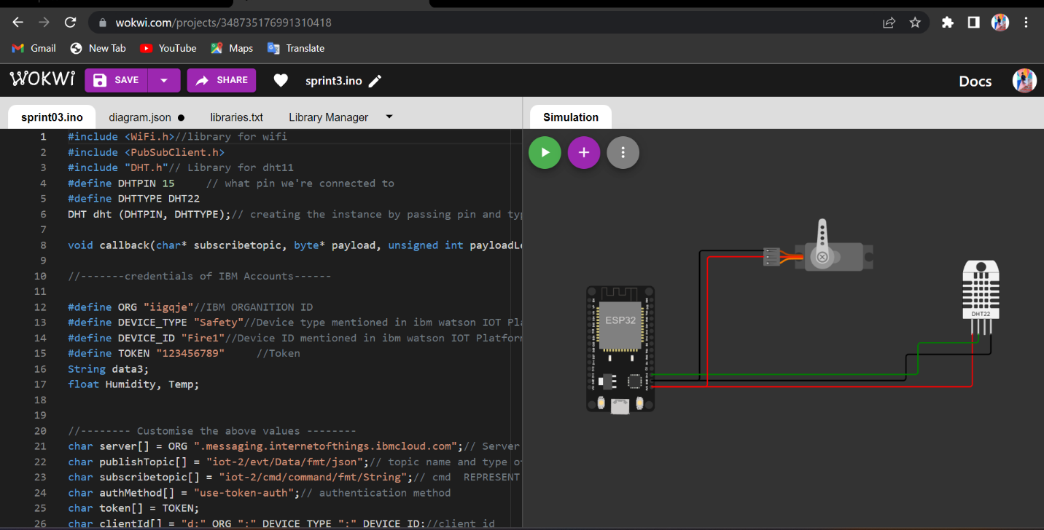

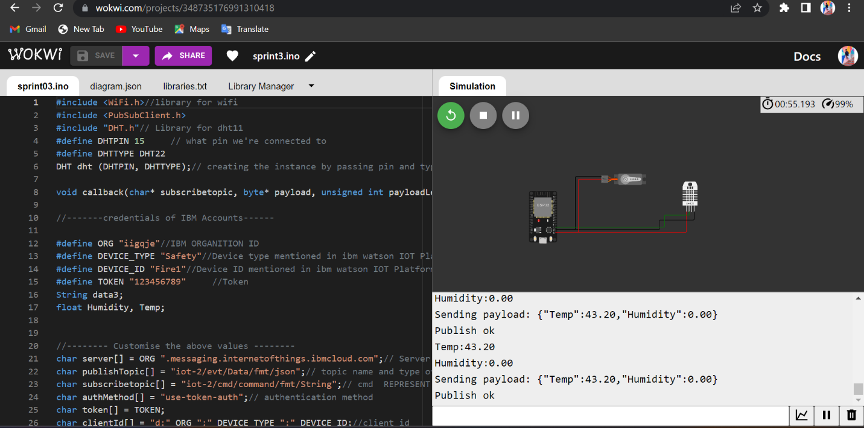

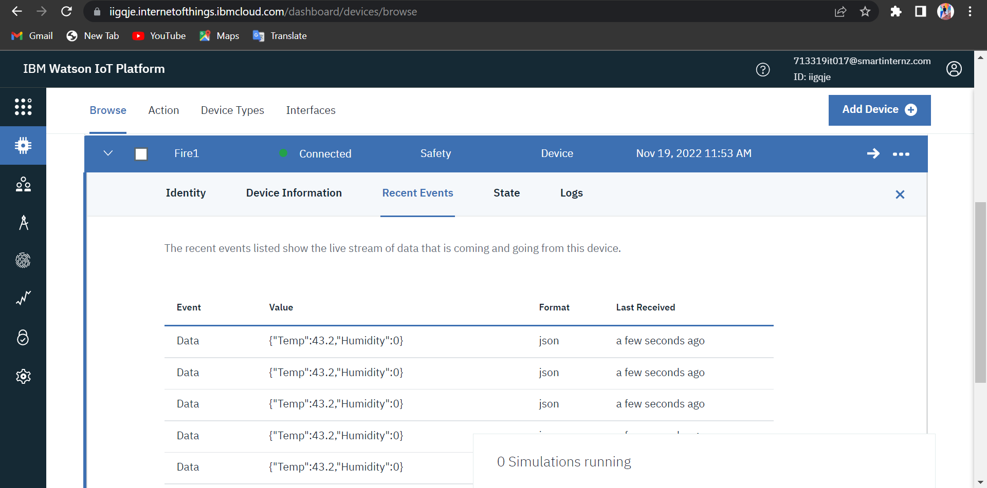

Wokwi Link: <https://wokwi.com/projects/348735176991310418>